# Sprint 3 | 10th November – 16th November

## **Sprint Overview**

### Preview

In the previous sprint we wanted to create a short mock-up of the game but opted instead to create an edited video. This week we wanted to complete the mock-up. We also felt that we needed to create a few more tasks that will help us start developing the game despite having expectations that the game development would start this sprint.

### Review

After 2 sprints of working as a team, our teamwork and efficiency was increasing. As a result, in this sprint we tried to use more team collaboration tools (e.g., GitHub or Google Docs) to further increase our efficiency.  By using a variety of Unity tools, we then managed to build a simple game with pipe selection, addition, and adding, but no rotation. For the documentation, we also discussed a backlog for future tasks, and created user stories, use cases, and CRC cards. Immediately following the client meeting, we had a further group meeting and discussed about how to make the pipes rotate and move, how to increase the complexity and difficulty of the game, and how to enrich user stories and use cases further. We also discussed the UI design and game art design in this sprint.

## **Tasks**

|  |  |  |
| --- | --- | --- |
| Code | Team Members | Tasks |
| **S3-T1** | Leo | Create a simple functional mock-up of the game (with pipe selection, addition, adding, but no rotation) using a variety of Unity tools. Create User Stories as you go. |
| **S3-T2** | Marcus | Set up a GitHub Repository to work on the game. |
| **S3-T3** | Marcus, Matthew, Claude, Zoe, Michelle, Shawn (Chin), Rachan | Study Unity, and use the simple mock-up game to understand some common tools we’ll be using. |
| **S3-T4** | Marcus | Add a character with basic movement animations to the game and make the pipes look more realistic using a model made in blender. |
| **S3-T5** | Whole Team | Discuss a backlog of future tasks to display. Add to the development backlog (see below). |
| **S3-T6** | Shawn (Chin) | Overview section for sprint documentation. |
| **S3-T7** | Rachan | Amend meeting records to sprint documentation. |
| **S3-T8** | Michelle | Write preview section for sprint documentation and meeting minutes for customer meeting. |
| **TBD** | Whole Team | Create User Stories for the game. |
| **TBD** | Whole Team | Create Use Cases for the game. |
| **TBD** | Whole Team | Create CRC cards for the game. |
| **TBD** | Whole Team | Create core functionality of the game. |
| **TBD** | Whole Team | Implement dungeon design to the game. |
| **TBD** | Whole Team | Add features. |

## **Backlog**

*Note:* The TBD tasks are un-ordered, un-designated tasks created during the task S3-T5.

|  |  |  |  |  |
| --- | --- | --- | --- | --- |
| Priority | Tasks | Date of Creation | Date of Completion | Status at End of Sprint |
| Whole Team 1 | S3-T3 | 10/11/21 | 10/11/21 | Complete |
| Leo 1 | S3- T1 | 10/11/21 | 13/11/21 | Complete |
| Marcus 1 | S3-T2 | 10/11/21 | 14/11/21 | Complete |
| Marcus 2 | S3-T4 | 10/11/21 | 16/11/21 | Complete |
| Whole Team 2 | S3- T5 | 10/11/21 | 16/11/21 | Complete |
| Shawn (Chin) | S3-T6 | 10/11/21 | 16/11/21 | Complete |
| Rachan | S3-T7 | 10/11/21 | 15/11/21 | Complete |
| Michelle | S3-T8 | 10/11/21 | 17/11/21 | Complete |
| Whole Team 4 | TBD | 10/11/21 | - | Not started |
| Whole Team 5 | TBD | 10/11/21 | - | Not started |
| Whole Team 6 | TBD | 10/11/21 | - | Not started |
| Whole Team 7 | TBD | 10/11/21 | - | Not started |
| Whole Team 8 | TBD | 10/11/21 | - | Not started |
| Whole Team 9 | TBD | 10/11/21 | - | Not started |

## **Meeting Records**

### Meetings

|  |  |  |  |
| --- | --- | --- | --- |
| Date & Time | Overview | Duration | Attended By |
| Tuesday (16th November 2021) - 18:00 - 18:52 | Internal Meeting | 52 minutes | All Team members |
| Wednesday (17th November 2021) - 12:00 - 12:17 | Client Meeting | 17 minutes | All Team members |
| Wednesday (17th November 2021) - 12:30 - 13:44 | Internal Meeting | 74 minutes | All Team members |

### Minutes

|  |  |
| --- | --- |
| Time | Wednesday 17th November 12:00-12:15 (Sprint 3) |
| Led By | Leo |
| Minutes Taken By | Michelle |
| Participants | Whole Team and Customer |

Agenda

1. Show mock-up of the game to client
2. Discuss plans for the next sprint

|  |  |
| --- | --- |
| Agenda Item | Summary |
| Show mock-up of the game to client | * Client liked the initial mock-up * It wasn’t clear to the client that there would be multiple pipes to choose from |
| Discuss plans for the next sprint | * Add a menu * Implement a scoring/point system * Pipe generation planning for the game to always be winnable * Client suggests pipes that can go back. The team felt that was unnecessary as you can access the right part of the screen with forward pipes * Store and display the high score on the menu * Client suggests start thinking about testing for difficulty, playability etc. |

Action Items

|  |  |
| --- | --- |
| No. | Action |
| 1 | Improve documentation |
| 2 | Implement plans for next sprint |

## **Customer Interview and Analysis**

**Interview Highlights:**

**Q (Team):** This is the initial demo of our game. Do you have any suggestions?

**A (Client):** I see that these pipes are on pre-set angles or welded on automatically. Maybe considering how to rotate these pipes is your next task.

**Q (Client):** Have you thought about adding game complexity? What do you think?

**A (Team):** We felt that adding pipe properties, such as pipes made of ice (which will melt due to heat), water falling from the sky (drains into pipes and drowns characters), obstacles (stones, etc., prevent players from placing pipes). We may consider these in the future.

**Q (Team):** This is an example of our half-finished documentation. Is there anything you think we need to add?

**A (Client):** Your user stories and use cases need to be expanded. They seem to have less content.

**Q (Client):** It looks like you haven't divided up your teams yet. Can you do that before the next meeting?

**A (Team):** Of course, we're going to do that right after this meeting.

**Analysis:**

* The client will play the game only towards the end when it is almost completely functional.
* The client approved a few ideas on adding complexity to the game (coins and obstacles).
* We should receive feedback on testing by non-developer team members. Make sure to ask the right kind of questions.
* Documentation needs more elaboration in user stories, use cases, etc.

## **User Stories**

The User Stories R5, R6, R7, and R8 were added this week.

### R5

|  |  |
| --- | --- |
| User Story: Character Dying R5 | Acceptance Criteria |
| As a Game Developer,  I want to kill the character if he falls too far behind,  So that the player has the goal to keep them alive. | Criterion 1.  **IF** the character is alive…  **WHEN** the character touches the left-hand edge of the screen…  **THEN** declare game over. |
| Priority: 5/5  Version: 1  Date: 13/11/21 |

### R6

|  |  |
| --- | --- |
| User Story: Rotating pipes R6 | Acceptance Criteria |
| As a Player,  I want to rotate selected pipes,  So that I can choose their rotation when I add them to the pipe system. | Criterion 1.  **IF** the character is alive…  **AND** the game isn’t paused…  **AND** the pipe piece is selected…  **WHEN** I press a left or right arrow key…  **THEN** rotate the pipe piece 90 degrees in the direction of the arrow key.  Criterion 2.  **IF** the character is dead…  **AND** the pipe piece is selected…  **WHEN** I press a left or right arrow key…  **THEN** do nothing.  Criterion 3.  **IF** the game can be paused  **AND** the game is paused...  **AND** the pipe piece is selected…  **WHEN** I press a left or right arrow key…  **THEN** do nothing. |
| Priority: 5/5  Version: 1  Date: 13/11/21 |

### R7

|  |  |
| --- | --- |
| User Story: Pipe pieces for selection R7 | Acceptance Criteria |
| As a Game Developer,  I want random pipe pieces to show up for the player which can always be used to beat the game,  So that the game is never impossible. | Criterion 1.  **IF** the player starts the game…  **WHEN** the player clicks to start or restart the game…  **THEN** continuously create random pipe pieces…  **AND** display these pipe pieces to the player at points along the game. |
| Priority: 5/5  Version: 1  Date: 13/11/21 |

### R8

|  |  |
| --- | --- |
| User Story: Score R8 | Acceptance Criteria |
| As a Player,  I want to see my score as I play,  So that I can see my progress. | Criterion 1.  **IF** the player is playing the game…  **THEN** their current score should be displayed. |
| Priority: 4/5  Version: 1  Date: 13/11/21 |

### R9

|  |  |
| --- | --- |
| User Story: High Score R9 | Acceptance Criteria |
| As a Player,  I want to see my high score,  So that I know what my best played game was. | Criterion 1.  **IF** the player is on the home menu…  **THEN** their high score should be displayed.    Criterion 2.  **IF** the player has just died...  **AND** they achieved their high score  **THEN** their high score should be saved |
| Priority: 4/5  Version: 1  Date: 13/11/21 |

## **User Interface Design**

### Game progress

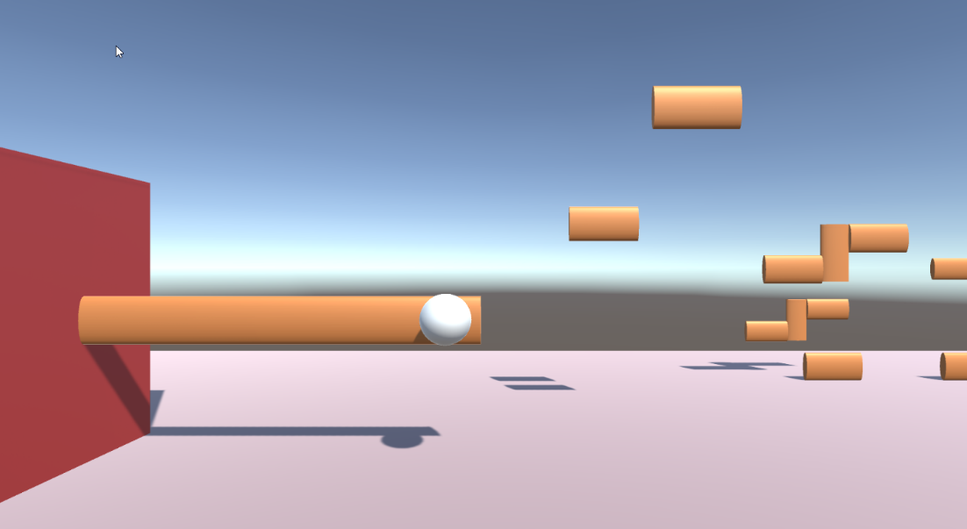

Initial prototype

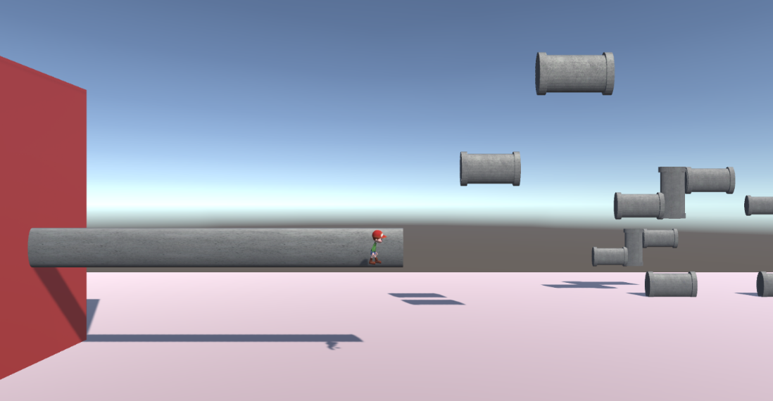

Character and pipes added

### Pipe creation in Blender

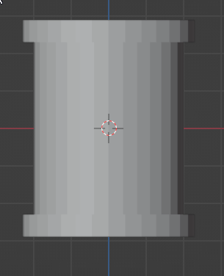

Straight Pipe

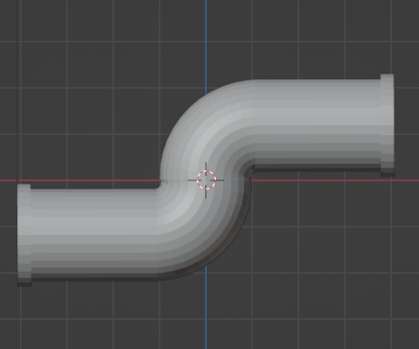

S shaped pipe

## **Exception Handling**

The challenges we faced during this sprint’s tasks are outlined below, alongside their respective solutions:

|  |  |  |
| --- | --- | --- |
| Tasks | Challenges | Solutions |
| S3- T1 | Figuring out how to structure the mock-up was difficult. | I used a similar process to CRC card creation to identify temporary classes, and a temporary flow of logic between classes. |
| S3- T2 | Making sure everyone understands how to setup and use GitHub and why we use it. | I created a step-by-step tutorial of how to use GitHub as well as a recording of myself walking through the process of setting up and using the repository on a local machine. |
| S3-T3 | Trouble getting the original version of the game available to everyone because the GitHub repository was still being created. | Went to campus to get faster WiFi, and transferred the .zip file by WeTransfer rather than using teams as was originally planned. |
| S3-T4 | The character animations cause slight movements of the character away from its collider. | I had to bake the positions into the animation pose so that the animations did not affect the position of the character |
| S3-T5 | Without having defined the requirements or design with user stories, use cases, and CRC cards, it was hard to identify detailed tasks to add to the backlog with respect to development. | Create more general future tasks, which could contain an array of more detailed smaller tasks yet are themselves ordered by priority within the backlog. |
| S3-T6 | N/A no challenge. | - |
| S3-T7 | N/A no challenge. | - |
| S3-T8 | N/A no challenge. | - |
|  | Responsibility for execution not taken. | Assigned roles and responsibilities to each team member. |